



***LAB TEST***

***MODULE: HTML5 – CSS3 & Bootstrap***

***Set02***

**Curriculum: Front End Programming**

**Total Marks : 20**

**Duration: 75 minute**

Do not write on this question paper and return it to the Invigilator after the examination.

Get resource for this examination from \\Data\Pub_Stud\HTML\ExamPict

And send your exam result to [aca@iviettech.vn](mailto:aca@iviettech.vn) email with title Exam + M35 + FE02 + your name.

Design a website as the following requirements:

**Requirements**:

Create a folder named Myweb to save website resources. Create images and styles folder are sub folder of Myweb to store image and style for website. [1 mark]

**Homepage**

* Use Unicode font.
* Set up a link from "Contact" to "Contact.html" page.

***More details:***

* 1. Create correct Layout (4 marks)
  2. Fill the content for this page (2 marks)
  3. Create menu and link correct contact page (3 marks)
  4. Set correct title and meta tag (1 mark)

**Contact Page**

* Use Unicode font.
* Forms

Check Validate Form:

+Name: Require

+Email: must to contain @ character

***More details:***

* 1. Create Layout and form (4 marks)
  2. Validate correct name (1 mark)
  3. Validate correct email (1 mark)

**Non-function requirements**

* Setup home and contact page can responsive on mobile (<480px), tablet(481-768 px) and desktop (>768px) size. (3 mark).

Homepage (**index.htm**)

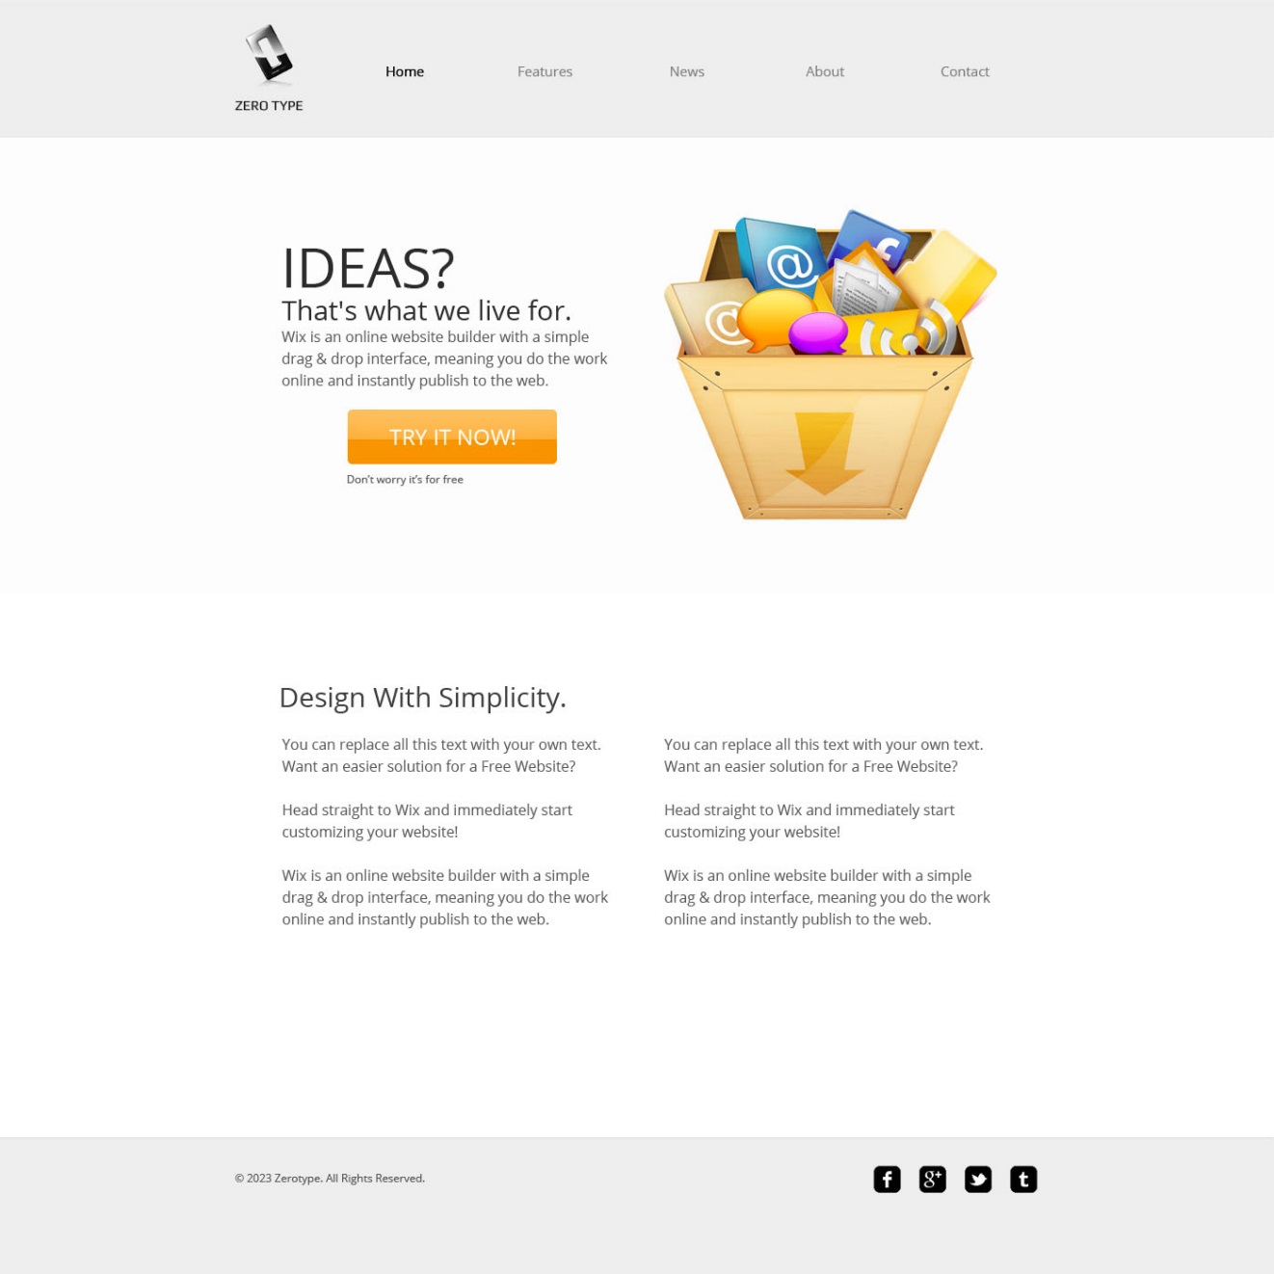

**Contact.htmt**

